COMPLETE NODE.JS DEVELOPER NOTES
(All Combined + Project Learnings)

Project Done during learning process
Task Manager App: https://github.com/notkirtann/task-manager-app
Weather App: https://github.com/notkirtann/weather-app-with-server-side-rendering-with-frontend
Learning files code link
https://github.com/notkirtann/JS-Cheat-Sheet (JavaScript Basics + Advanced Backend Concept)

Based on:
- The Complete Node.js Developer Course (3rd Edition) — Andrew Mead
- Node.js Bootcamp by Hitesh Choudhary & Piyush Garg
- Practical Project: App manager (Node + Express + MongoDB + Mongoose + Postman + Node mailer + File Upload)

What is Node.js?
- Node.js is a JavaScript runtime environment built on Chrome’s V8 engine.
- It allows running JavaScript outside the browser, mainly for server-side applications.
- Adds features like file system access, HTTP servers, etc., which browsers can’t do.
- Non-blocking I/O model → handles multiple operations concurrently using event loop.
Browser JS | Node.js
Has window and document | Has global and process
DOM access | File system, OS access
Blocking APIs | Non-blocking async APIs

Core Node Modules
Module | Purpose
fs | File system operations
path | Handle file & directory paths
OS | Info about operating system
http | Create web servers & APIs
https | Create secure SSL servers
events | Event-driven programming

File System (fs) Module
- require('fs') to use.
- File operations (Sync = blocking, Async = non-blocking):
fs.writeFileSync('notes.txt', 'Hello!');
fs.appendFileSync('notes.txt', ' More text.');
fs.readFileSync('notes.txt', 'utf-8');
fs.unlinkSync('notes.txt'); // delete
fs.mkdirSync('folder', { recursive: true });
fs.rmdirSync('folder');

Async Version (Non-blocking)
fs.readFile('notes.txt', 'utf-8', (err, data) => {
if (err) return console.log(err);
console.log(data);
});

Modules in Node.js
- Every JS file = a separate module.
Use CommonJS syntax:
- const x = require('./file.js');
- module.exports = { functionName };
Or ES Modules:
- import something from './file.js';
- export default something;
- Controlled via package.json:
  - "type": "module" → ES Modules
  - "type": "commonjs" → CommonJS

Events & EventEmitter
- Node.js core is event-driven.
- You can use events via the events module.
import EventEmitter from 'events';
const event = new EventEmitter();
event.on('greet', () => console.log('Hello!'));
event.emit('greet');
Useful Methods:
- .on() → listen for event
- .emit() → trigger event
- .once() → run once only
- .removeListener() → stop listening
- .listeners() → check listeners count

npm & External Packages
- Install packages with:
- npm install chalk validator yargs
- npm install -g nodemon
- Store dependencies in package.json.
- Use version control (^ and ~) for updates.
Symbol | Meaning
~ | Auto-update patch versions
^ | Auto-update minor versions

Command Line Arguments
- process.argv → access command-line args.
- Better alternative → yargs.
Example:
import yargs from 'yargs';
const argv = yargs(process.argv.slice(2)).argv;
console.log(argv.name);

Asynchronous Basics
- Node.js executes code via:
  - Call Stack
  - Callback Queue
  - Event Loop
- Uses callback functions, Promises, or async/await to handle async code.

HTTP Module & REST Basics
Common HTTP Methods:
Method | Purpose
GET | Retrieve data
POST | Send new data
PUT | Replace existing data
PATCH | Update partially
DELETE | Remove data
Status Codes:
Code | Meaning
200 | OK
201 | Created
400 | Bad Request
401 | Unauthorized
404 | Not Found
500 | Internal Server Error

Express.js (Node.js Framework)
- Express simplifies creating Node servers.
- Handles routing, middleware, and responses easily.
import express from 'express';
const app = express();

app.use(express.json());

app.get('/', (req, res) => {
res.send('Hello Express!');
});
app.listen(3000);

Middleware
Middleware = functions that process requests before reaching routes.
app.use((req, res, next) => {
console.log(req.method, req.url);
next();
});
Types:
- Global Middleware → runs for all routes.
- Route-level Middleware → specific to one route.

Serving Static Files
app.use(express.static('public'));
Default file = index.html for /.

MVC Architecture
- Model → database layer (Mongoose models)
- View → frontend (HTML, React, etc.)
- Controller → logic between routes and models

Environment Variables
- Store secrets and keys in .env
PORT=8000
TOKEN=abc123
- Access via dotenv:
import dotenv from 'dotenv';
dotenv.config();
console.log(process.env.PORT);
In some files (like mongoose.js), environment variables were loaded using a custom path resolution instead of default dotenv configuration.
This helps when the .env file is placed at a different directory level and avoids missing variable errors during database initialization.

MongoDB Concepts
SQL vs NoSQL
SQL | NoSQL
Tables | Collections
Rows | Documents
Fixed Schema | Flexible Schema

BSON vs JSON
JSON | BSON
Human-readable | Binary format
Slower parsing | Faster parsing
Fewer data types | Supports more (Date, ObjectId, etc.)

Mongo Shell Commands
use mySchoolDB
db.createCollection("students")
db.students.insertOne({ name: "Kirtan", age: 22 })
db.students.find()
db.students.updateOne({ name: "Kirtan" }, { $set: { age: 23 } })
db.students.deleteOne({ name: "Kirtan" })

Mongoose ODM
- Mongoose = Object Data Modeling (ODM) tool.
- Defines schema and adds validation.
import mongoose from 'mongoose';

mongoose.connect('mongodb://127.0.0.1:27017/test');
const userSchema = new mongoose.Schema({
name: String,
age: Number,
});

const User = mongoose.model('User', userSchema);
Mongoose Virtual Relationships
The User model includes a virtual field that creates a logical relationship between User and Task documents.
This virtual does not store data in MongoDB but allows population:
userSchema.virtual('tasks', {
ref: 'Task',
localField: '_id',
foreignField: 'ownerId'
})
This allows fetching all tasks of a user using populate().

Data Validation & Sanitization
You used:
- validator.isEmail()
- validator.isStrongPassword()
- .trim(), .minlength, .max
import validator from 'validator';
email: {
type: String,
required: true,
validate(value) {
if (!validator.isEmail(value)) throw new Error('Invalid Email');
}
}

Advanced Mongoose Features (Learned from Task Manager App)
Schema Relationships
Used ref and populate():
userId: {
type: mongoose.Schema.Types.ObjectId,
ref: 'User'
}
Task.find().populate('userId', 'name age');
Model Methods & Statics
userSchema.statics.findByCredentials = async (email, password) => {
const user = await User.findOne({ email });
const isMatch = await bcrypt.compare(password, user.password);
return user;
};
Middleware (pre-save)
Auto-hash passwords:
userSchema.pre('save', async function(next) {
if (this.isModified('password'))
this.password = await bcrypt.hash(this.password, 8);
next();
});
Data Constraints
- Enums (for player positions)
- Min/max values
- Boolean defaults
- Relationships with ObjectId
Error Handling
Graceful error responses:
res.status(400).send({ error: error.message });
and validation for ObjectIds:
if (!mongoose.Types.ObjectId.isValid(req.params.id)) {
return res.status(400).send({ error: "Invalid ID" });
}
User toJSON Method
The User model overrides the default toJSON method so that whenever a user object is sent as a response:
- password
- tokens
- avatar (binary)
are removed automatically.
This prevents leaking sensitive data in API responses.

REST API Design (in Practice)
Example Routes:
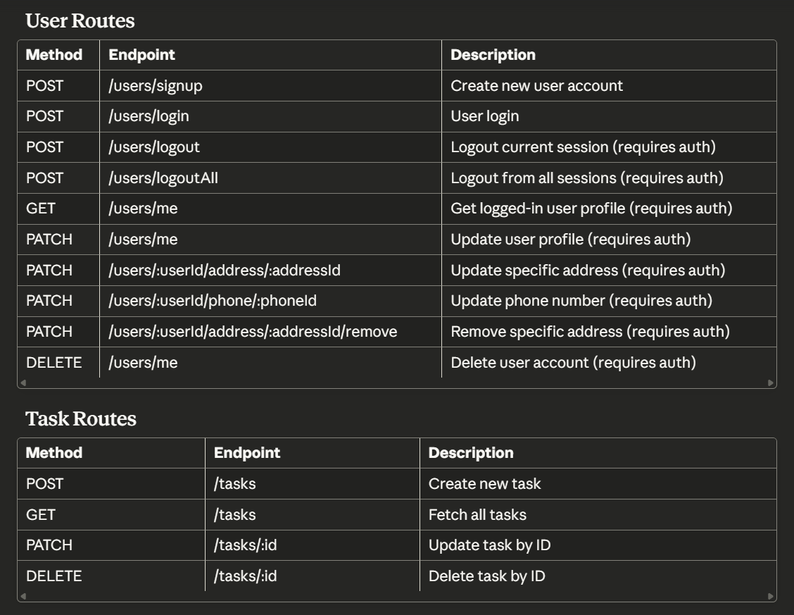
RESTful Principles:
- Stateless communication
- JSON as data exchange format
- Consistent resource naming
- Proper HTTP methods & status codes

Project: Task Manager App Learnings
Concept | Description
Express Setup | Built routes for Clubs and Players
Mongoose Models | Created Club and Player schemas with relationships
Controllers | Separated logic for CRUD operations
Password Hashing | Used bcrypt for secure storage
Async/Await | Used for all database and route handlers
Error Handling | Used structured try-catch with proper status codes
Population | Linked players to clubs using populate()
Schema Middleware | Added password hashing in pre('save')
Stateless Auth Logic | Implemented login with password comparison
Clean Project Architecture | Followed MVC pattern (Models, Controllers, Routes)

Git & GitHub Commands Recap
git init
git add .
git commit -m "Initial commit"
git branch -M main
git remote add origin <repo-url>
git push -u origin main
Generate SSH Key:
ssh-keygen -t rsa -b 4096 -C "your_email"
eval $(ssh-agent -s)
ssh-add ~/.ssh/id_rsa

JSON Web Tokens
npm i jsonwebtoken
Route can be public and private.
Main two routes that can should be public are signup and login rest will be hidden inside authentication
Jwt is most used authentication method where token is generate on login request which we check for authenticate and authroize whether person is allowed aur not
We can also make token expire after certain time also (feature of jwt)
Multi-Session Token Handling
The User model stores tokens in an array, allowing:
- multiple active sessions
- logout of only one session
- logout-all functionality
This design supports large-scale applications where multiple logins per user are required.

import jwt from 'jsonwebtoken'

const jwtFunction = async()=>{

//for creating web token
const authToken = jwt.sign(
{
email:'kirtan123@gmail.com' //thing we want embedded in it
},
'thisismypass', //unique code that helps in verify
{
expiresIn : '7 min' //expiring time (optional)
})
console.log(authToken);

//for verifying web token
const data =jwt.verify(authToken,'thisismypass') (taken token,unique code)
to verify the authen
console.log(data);
}
jwtFunction()

Authentication Middleware
A custom authentication middleware was implemented to verify JWT tokens on protected routes.
It does the following:
- Extracts the token from the Authorization header.
- Verifies the token using jwt.verify() and the secret key.
- Finds the corresponding user whose token array still includes the token.
- Attaches the user and token to the request.
- Throws a 401 error if authentication fails.
This ensures only logged-in users can access private endpoints.

CREATING LOGIN LOGIC
app.use('/clubs', clubRoutes);

router.post("/login",controllers.clubLogin)

const clubLogin = async(req,res)=>{
try{
const club = await Club.findByCredentials(req.body.email,req.body.password)
const token = await club.genAuthToke()
res.send(club)
}catch(e){
res.status(400).send('Invalid Login')
}
}

clubSchema.statics.findByCredentials = async (email,password) => {
const club = await Club.findOne({email})

if(!club){
throw new Error('unable to login')
}
const isMatch = await bcrypt.compare(password,club.password)

if(!isMatch){
throw new Error('Unable to login')
}
return club;
}

So static methods are accessible on the model sometimes called model methods and our methods are accessible on the instances sometimes called instance methods.

User/Task Relationship
In task model create a property called onwer/author/admin of your wish
Inside it
type: mongoose.Schema.Types.ObjectId, -- tells it objected from any model
required: true,
ref: 'User' -- for refrencing other model name User in our case
and to have access of all data of user in your owner property in object we use cmd all
populate which will link both owner
eg
await task.populate(‘owner’)
Scehma.Virtual will help us link both the model together with help of local and foreign key relationships
Ex:
userSchema.virtual('tasks',{
ref : 'Task', ----------------// ref to other model
localField : '_id', ------------//id that is stored as part of model in other id
foreignField: 'onwerId' ------- // which is holding id of other model
})
Authorization Logic for Resource Ownership
All task operations ensure that users can access only their own tasks.
This is done by always checking ownerId: req.user._id when fetching, updating, or deleting tasks.

NOV Learning
Environment variables properly loaded (.env)
JWT authentication system
Protected endpoints with middleware (express middleware)
Club registration & login working
Passwords hashed and validated
Token-based session management
Proper error handling for auth
Advance Postman Handling

Timestamp, Paginating, Filtering, Sorting
Timestamp = in your Schema create new object in that timpestamp : true
Filtering = in your route where you need filtering to be done use condition statement on particular data field which you are using filter data like in given code based on completed filtering is done
Paginating = limit the data to be see view by customer like 100 collection limit 10 will show first 10 also skip = 10 will skip first 10 fields of collection.
Sorting = will sort in asc desc arrounding
Ex. of combined filtering sorting and paginating
const getAllTasks = async (req, res) => {
const match = { ownerId: req.user._id }

if(req.query.completed){
match.completed = req.query.completed === 'true'
}
const limit = parseInt(req.query.limit) || 5
const skip = parseInt(req.query.skip) || 0
const sort = {}

if(req.query.sortBy){
const parts = req.query.sortBy.split(':')
sort[parts[0]]= parts[1]==='desc' ? -1 : 1
}

try {
const tasks = await Task.find(match).limit(limit).skip(skip).sort(sort)
res.send(tasks);
} catch (error) {
res.status(500).send({ error: "Error fetching tasks" });
}
};

GET /tasks?completed=true
GET /tasks?limit=10&skip=20
GET /tasks?sortBy=createdAt:desc
GET /tasks?sortBy=description:asc
These help customize data retrieval based on client needs.
FILE UPLOADS
Npm i multer – library used for file uploads and all managed by express library people only because express don’t have direct functionality o support to file uploads
import multer from 'multer'
const upload = multer({
dest : 'images'
})
router.post("/me/avatar",auth,upload.single('avatar'),userController.uploadAvatar,(error,req,res,next)=>res.status(400).send({'error': error.message}))

In project directory images name folder will be created and I will have the photo you uploaded from postman in binary format
Custom Multer Error Handling
A separate error-handling middleware was added right after multer's upload middleware.
This ensures multer errors such as invalid file types or file size limit violations return proper JSON error responses instead of crashing the server.
VALIDATE FILE UPLOADS
Validation is done using different thing like can be file size and file type like jpeg etc
For this in multer there are function/field called limit its object and have multiple fields like fileSize etc other field of file type in fileFilter(req,file,callback)
Ex:
const upload = multer({
dest: 'avatars', // don’t provide if want to store in database
limits: {
fileSize: 2000000 // 2MB
},
fileFilter(req,file,cb) {
//logic and function here
}
})
Add avatar as part of schema and type should be Buffer
avatar: {
type: Buffer
},
This will help store data in database can only be possible when you don’t provide dest property in multer
Now you can create delete save avatar using route
Ex:
const uploadAvatar = async (req,res) => {
const buffer = await sharp(req.file.buffer).resize({width:250,height:250}).png().toBuffer()
req.user.avatar=buffer;
await req.user.save()
res.send('avatar added successfully')
}
const showAvatar = async (req,res)=>{
try {
const userProfile = await req.user.avatar
res.set('Content-Type','image/png')
res.send(userProfile)
} catch (error) {
res.send('Can\'t find Profile Picture')
}
}

const deleteAvatar = async (req,res) =>{
req.user.avatar = undefined
await req.user.save()
res.send('avatar deleted succesfully')
}

Database saves data in binary form so to view it you have to use method called set which will automatically help us to get visual of image that can be done using
res.set('Content-Type','image/png')
rresize and coverting of files while saving uploaded file/picture can be done using npm module called sharp
npm i sharp
Avatar Storage as Binary
User avatars are stored inside the database as a Buffer.
The workflow is:
- multer processes the upload
- sharp resizes and converts it
- the resulting buffer is saved in the avatar field
- retrieving the avatar uses res.set('Content-Type', 'image/png')
This avoids storing files on disk and keeps the system database-driven.

EMAIL SENDING

Email sending can be done using multiple apps in your app but two popular library/ api are
Sendgrid and Nodemailer

Using Node mailer
Npm I nodemailer (for production use)
Nodemailer.createTransport is the main function tell about service we want to use port we want to use and auth like user pass which we want to use for sending mail.
import dotenv from 'dotenv'
dotenv.config()
import nodemailer from 'nodemailer'

const auth = nodemailer.createTransport({
service: 'gmail',
secure: true,
port: 465,
auth: {
user: process.env.USER_EMAIL,
pass: process.env.USER_PASS

}
})

Than we can create seprate exporting function acc to our usage for joining and update
That will we execute using main function that was used to create nodemailer transport dot sendmail(content_to_send)
Ex:

export const welcomeMail =async (emailofUser) => {
const mailThis = {
from: process.env.USER_EMAIL,
to: emailofUser,
subject: "Welcome to task-manager-app ",
html :`
<h2>Hello Sir, </h2>
<p>Welcome to <strong>Task Manager App</strong>!</p>
<p>Your account has been successfully created. Start managing your tasks today 🚀</p>
<br>
<p>Best Regards, <br>Task Manager Team</p>
`
};
await auth.sendMail(mailThis)
};

For adding this functionality we can add these function inside that route’s controllers
export const deleteMail =async (emailofUser) => {
const mailThis = {
from: process.env.userEMAIL,
to: emailofUser,
subject: "Sad to see you go from task-manager-app ",
html :`
<h2>Hello Sir,</h2>
<p>We are very sad to see you leave <strong>Task Manager App</strong>!</p>
<p>Your account has been successfully deleted.</p>
<br>
<p>Best Regards,<br>Task Manager Team</p>
`
};
await auth.sendMail(mailThis)
};

Environment Variable Consistency
During implementation, one inconsistency was noticed:
In deleteMail(), process.env.userEMAIL should match the correct variable USER_EMAIL.
Keeping environment variable naming consistent avoids email delivery bugs.

Summary
Topic | Skill Learned
Core Node.js | Modules, fs, events, path
Async Concepts | Callbacks, Promises, Event Loop
Express.js | Routing, middleware, server setup
REST APIs | CRUD, status codes, structure
MongoDB | CRUD, NoSQL concepts
Mongoose | Schema design, validation, relationships
Security | Password hashing with bcrypt
Validation | Using validator.js
Architecture | MVC pattern
Git & GitHub | Version control and deployment
Environment | dotenv and config setup
 | In SHORT
Core Node.js concepts
Async fundamentals
Express routing/middleware
REST API conventions
MongoDB + Mongoose advanced usage
Password hashing and security
JWT authentication
Nested subdocument operations
File uploads and image processing
Email notifications
Environment configuration
Query features (filtering, sorting, pagination)
Full MVC architecture

